Deepavali Festival

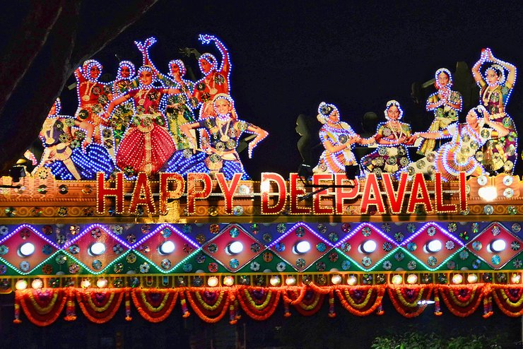

Every year, Little India turns it on for Deepavali with its eye-popping light-up.

Just when you think the street lights can’t get any more dazzling, out come massive peacocks, lotus flowers, oil lamps and Mahalakshmi, the goddess of wealth and prosperity in Hinduism, guarding Serangoon Road.

The lights will switch on from 7pm till midnight until 6 December 2020. You seriously can’t miss it.

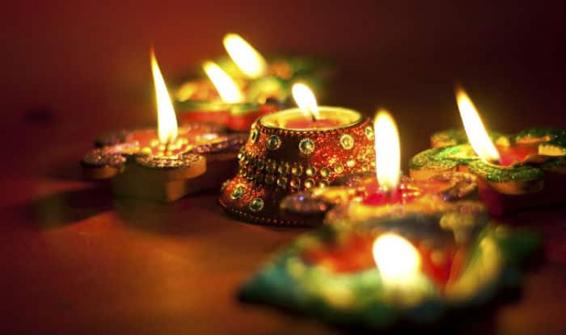

Interestingly, Singapore Deepawali lasts for a week. With vivid hues of warm golden lights, the Hindu community all over Singapore celebrates the festival spreading joy and cheer. Indian festivals in Singapore are celebrated with full pomp and show.

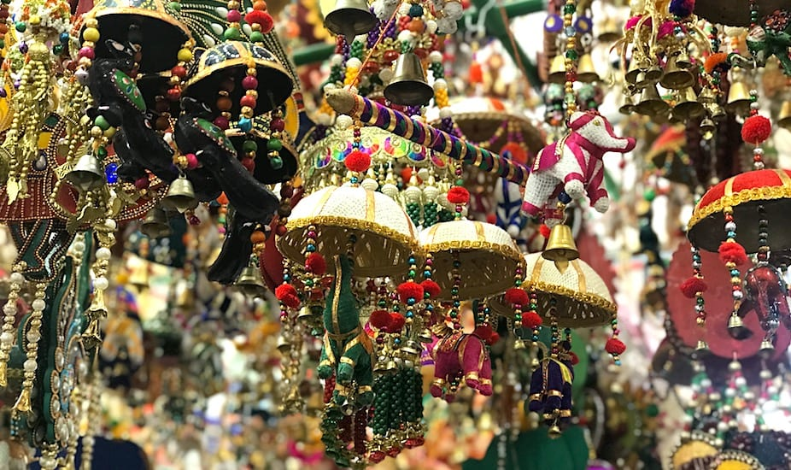

With vivid hues of warm golden lights, the Hindu community all over Singapore celebrates the festival spreading joy and cheer. Indian festivals in Singapore are celebrated with full pomp and show.

Deepavali marks the return of Lord Rama, who was the seventh incarnation of Vishnu, from a fourteen year exile.

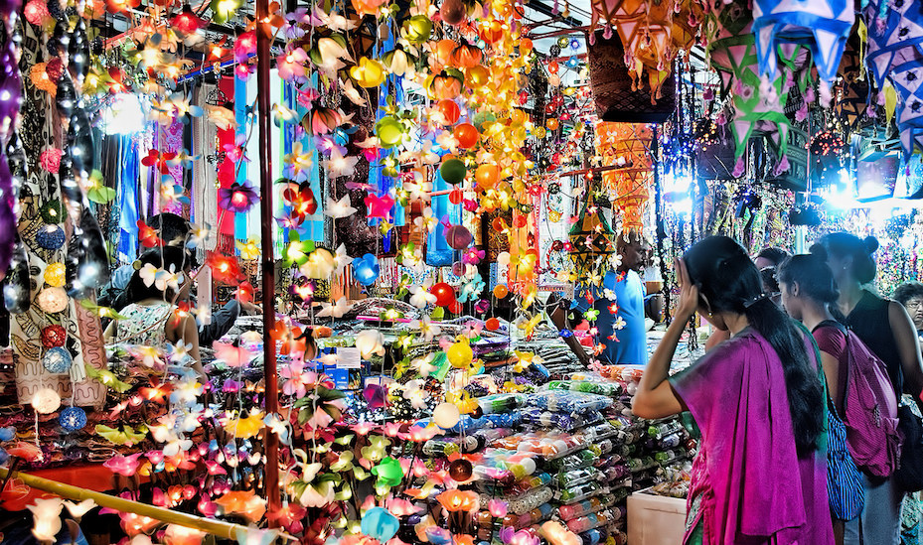

The winning lanterns will be displayed along Pagoda Street until the Mid-Autumn Festival night.

**Don’t miss:**Exquisite delicacies trying visiting a local’s home  
**When:**14th November 2020